**Chandigarh College of Engineering & Technology (Degree Wing)**

Department of Computer Science & Engineering

**Semester**: CSE 3rd **Subject & Code:** Database Systems,

CS- 302

**Assignment-2**

|  |  |  |  |  |
| --- | --- | --- | --- | --- |
| **S.No.** | **Year** | **SET No.** | **First line of question** | **Answer** |
|  | 2015 | 1 | Consider an Entity-Relationship (ER) model in which entity sets E1 and E2 are connected by an m : n relationship R12. | 4 |
|  | 2015 | 3 | Consider the relation X(P,Q,R,S,T,U) with the following set of functional dependencies | C |
| 3. | 2016 | 1 | A database of research articles in a journal uses the following schema.  (VOLUME, NUMBER, STARTPAGE, | B |
| 4 | 2019 | 1 | Let the set of functional dependencies F = {QR → S, R → P, S → Q} hold on a relation schema X = (PQRS). X is not in BCNF. | C |
| 5 | 2020 | 1 | Consider a relational table R that is in 3NF but not in BCNF. | D |
| 6 | 2021 | 1 | Consider the relation R(P Q S T X Y Z W) with the following functional dependencies. | D |
| 7 | 2022 | 1 | In a relational data model, which one of the following statements is TRUE? | A |
| 8 | 2022 | 3 | Consider a relation R(A B C D E) with the following three functional dependencies. | 8 |
| 9 | 2024 | 2 | A functional dependency F →Y is termed as a useful functional dependency if and only if it satisfies all the following three conditions | 50 |
| 10 | 2024 | 1 | The symbol → indicates functional dependency in the context of a relational database. | B,C,D |

**GATE CSE 2015 Set 1**

Numerical

Consider an Entity-Relationship (ER) model in which entity sets E1 and E2 are connected by an m : n relationship R12. E1 and E3 are connected by a 1 : n (1 on the side of E1 and n on the side of E3) relationship R13.

E1 has two single-valued attributes a11 and a12 of which a11 is the key attribute. E2 has two single-valued attributes a21 and a22 of which a21 is the key attribute. E3 has two single-valued attributes a31 and a32 of which a31 is the key attribute. The relationships do not have any attributes.

If a relational model is derived from the above ER model, then the minimum number of relations that would be generated if all the relations are in 3NF is _______.

**Answer**

Correct answer is 4

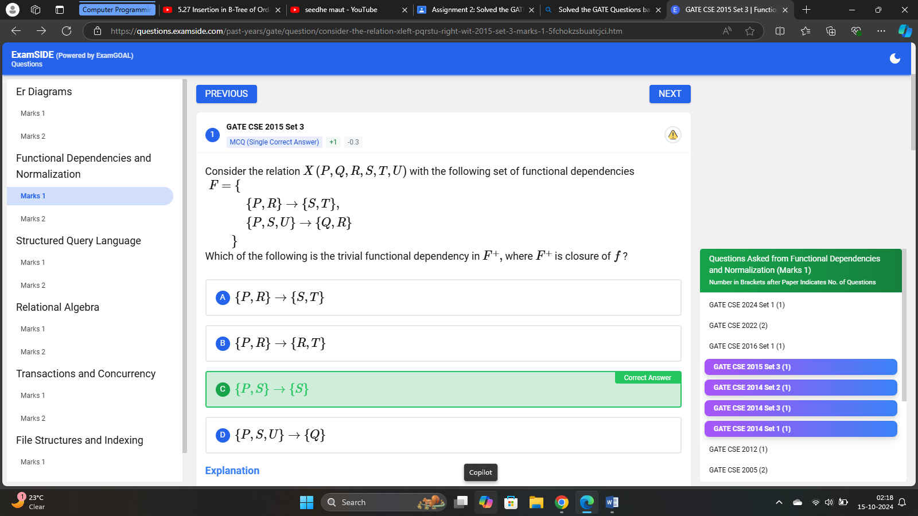

GATE 2016

A database of research articles in a journal uses the following schema.

(VOLUME, NUMBER, STARTPAGE, ENDPAGE, TITLE, YEAR, PRICE)

The primary key is **(VOLUME, NUMBER, STARTPAGE, ENDPAGE)** and the following functional dependencies exist in the schema.

(VOLUME, NUMBER, STARTPAGE, ENDPAGE) → TITLE

(VOLUME, NUMBER) → YEAR

(VOLUME, NUMBER, STARTPAGE, ENDPAGE) → PRICE

The database is redesigned to use the following schemas.

(VOLUME, NUMBER, STARTPAGE, ENDPAGE, TITLE, PRICE)

(VOLUME, NUMBER, YEAR)

Which is the weakest normal form that the new database satisfies, but the old one does not?

A1NF

B2NF

C3NF

D BCNF

Answer : B

**GATE CSE 2019**

Let the set of functional dependencies  
  
F = {QR → S, R → P, S → Q}  
  
hold on a relation schema X = (PQRS). X is not in BCNF. Suppose X is decomposed into two schemas Y and Z, where Y = (PR) and Z = (QRS).  
  
Consider the two statements given below.  
  
I. Both Y and Z are in BCNF  
II. Decomposition of X into Y and Z is dependency preserving and lossless  
  
Which of the above statements is/are correct?

A

I only

B

Neither I nor II

C

II only

D

Both I and II

Answer :C

**GATE CSE 2020**

MCQ (Single Correct Answer)

Consider a relational table R that is in 3NF, but not in BCNF. Which one of the following statements is TRUE?

A

A cell in R holds a set instead of an atomic value.

B

R has a nontrivial functional dependency X → A, where X is not a superkey and A is a non-prime attribute and X is not a proper subset of any key

C

R has a nontrivial functional dependency X → A, where X is not a superkey and A is a non-prime attribute and X is a proper subset of some key.

D

R has a nontrivial functional dependency X → A, where X is not a superkey and A is a prime attribute.

Answer:D

**GATE CSE 2021 Set 1**

MCQ (Single Correct Answer)

Consider the relation R(P, Q, S, T, X, Y, Z, W) with the following functional dependencies.

PQ → X; P → YX; Q → Y; Y → ZW

Consider the decomposition of the relation R into the constituent relations according to the following two decomposition schemes.

D1 : R = [(P, Q, S, T); (P, T, X); (Q, Y); (Y, Z, W)]

D2 : R = [(P, Q, S); (T, X); (Q, Y); (Y, Z, W)]

Which one of the following options is correct?

A

D1 is a lossy decomposition, but D2 is a lossless decomposition.

B

Both D1 and D2 are lossless decompositions.

C

Both D1 and D2 are lossy decompositions.

D

D1 is a lossless decomposition, but D2 is a lossy decomposition.

Answer: D

**GATE CSE 2022**

MCQ (Single Correct Answer)

In a relational data model, which one of the following statements is TRUE?

A

A relation with only two attributes is always in BCNF.

B

If all attributes of a relation are prime attributes, then the relation is in BCNF.

C

Every relation has at least one non-prime attribute.

D

BCNF decompositions preserve functional dependencies.

Answer: A

Relation with 2 attributes always in BCNF

R(AB) {A → B} ⇒ BCNF

{B → A} ⇒ BCNF

{A → B, B → A} ⇒ BCNF

{No non-trivial FD's} ⇒ BCNF

∙ If all prime attributes than relation always in 3NF but may not BCNF.

∙ Not mandatory of atleast one non-prime attribute in RDBMS table.

∙ Not every relation can decompose into BCNF with dependency preserving.

**GATE CSE 2022**

Numerical

Consider a relation R(A, B, C, D, E) with the following three functional dependencies.

AB → C ; BC → D ; C → E;

The number of superkeys in the relation R is _________.

Answer :8

AB+ = ABCDE

∴ AB : Candidate key

Non prime attribute = C, D, E

∴ Number of superkeys = 23 = 8. Those are AB, ABC, ABD, ABE, ABCD, ABCE, ABDE, ABCDE. In super key candidate key should always present.

**GATE CSE 2024 Set 2**

Numerical

A functional dependency F:X→Y is termed as a useful functional dependency if and only if it satisfies all the following three conditions:

* X is not the empty set.
* Y is not the empty set.
* Intersection of X and Y is the empty set.

For a relation R with 4 attributes, the total number of possible useful functional dependencies is _________

Answer:  50

**Explanation**

To determine the total number of possible useful functional dependencies for a relation R with 4 attributes, we need to carefully analyze the conditions specified for a functional dependency F:X→Y to be considered useful.

Let's denote the 4 attributes by A,B,C,D.

A useful functional dependency F:X→Y must satisfy the following conditions:

* X is not the empty set.
* Y is not the empty set.
* The intersection of X and Y is the empty set (i.e., X∩Y=∅).

Given that the relation R has 4 attributes, there are a total of 24−1=15 possible non-empty subsets for X. Similarly, there are 24−1=15 possible non-empty subsets for Y. However, we must ensure that X∩Y=∅.

The total number of useful functional dependencies can be determined by counting all valid combinations of X and Y such that X and Y are disjoint subsets of {A,B,C,D}.

Let's approach this step by step:

1. We need to choose X such that it's a non-empty subset of {A,B,C,D}. Each non-empty subset can be chosen in 24−1=15 ways.
2. For a given X, Y must be a non-empty subset of the remaining attributes {A,B,C,D}∖X. The number of attributes left after choosing X is 4−|X|.
3. The number of non-empty subsets of the remaining attributes is 24−|X|−1.
4. We need to sum these counts over all possible sizes of X.

Summarizing, we compute the total number of useful functional dependencies:

∑k=14(4k)⋅(24−k−1)

Where (4k) represents the number of ways to choose X with k attributes.

Calculating each term:

* For k=1: (41)⋅(24−1−1)=4⋅(8−1)=4⋅7=28
* For k=2: (42)⋅(24−2−1)=6⋅(4−1)=6⋅3=18
* For k=3: (43)⋅(24−3−1)=4⋅(2−1)=4⋅1=4
* For k=4: (44)⋅(24−4−1)=1⋅(1−1)=1⋅0=0

Adding all these, the total number of useful functional dependencies is:

28+18+4+0=50

Thus, the total number of possible useful functional dependencies is 50.

**GATE CSE 2024 Set 1**

MCQ (More than One Correct Answer)

The symbol → indicates functional dependency in the context of a relational database. Which of the following options is/are TRUE?

A

(X, Y) → (Z, W) implies X → (Z, W)

B

Correct Answer

(X, Y) → (Z, W) implies (X, Y) → Z

C

Answer

((X, Y) → Z and W → Y) implies (X, W) → Z

D

Correct Answer

(X → Y and Y → Z) implies X → Z

## Explanation

Option A:

(X,Y)→(Z,W) implies (X→(Z,W)).

This is not always true. Knowing that the pair (X, Y) determines (Z, W) does not necessarily mean that X alone determines (Z, W).

Option B:

(X,Y)→(Z,W) implies (X,Y)→Z.

This is true. If the pair (X, Y) determines (Z, W), it certainly determines Z individually as Z is part of (Z, W).

Option C:

 and ((X,Y)→Z and W→Y) implies ((X,W)→Z).

This is true due to the principle of transitivity in functional dependencies.

Option D:

 and (X→Y and Y→Z) implies X→Z.

This is true by the transitive property of functional dependencies.

Thus, the options that are TRUE are:

**Option B, Option C, and Option D**.